DBMS

# FUNCTIONAL DEPENDENCY:

* Consider two attributes or set of attributes A and B.
* If we can search the value of B through A, then There exists a FD between A and B:
$$A→B$$

* Now there are some assumptions that are to be made.
* Same tuples of A must have same corresponding tuples in B.
* If two or more tuples of A have different corresponding values for B, there is no FD.
* But if different tuples of A have same values for B, then there may be a FD.
* There is a short way to find out FD:
  + Check whether all tuples of A are distinct. If yes then FD exists.
  + Check whether all tuples of B are same. If yes then FD exists.
  + If none of above holds, then check whether two tuples of A have different values for B. If yes then no FD.
* This is not a mathematical function. But actually, a simple lookup operation.

# CLOSURE OF ATTRUBUTES:

* A closure set of an attribute/set F is actually a group of attributes which are functionally dependent on F. Denoted by $F^{+}$.
* We can establish a closure property by looking at different FDs.
* Armstrong’s axioms (Primary):
  + Reflexivity: $ifX⊆Y,thenY→X$
  + Augmentation: $ifX→Y,thenXZ→XY$
  + Transitivity: $ifX→Y∧Y→Z,thenX→Z$
* We are actually identifying total attributes that are functionally dependent of some set of or a single attribute.

# IRREDUCIBLE FD OR CANONICAL FORM:

* Some FDs have redundant attributes with them.
* We can remove them by a step by step process:
  + We first decompose the FDs.
  + Then we calculate the closure set of each FD and determine the redundant attribute.
  + We then apply union.
* After this process we get an irreducible FD or canonical form.

# KEYS:

* An attribute or set of attributes that uniquely identifies other attributes.
* Super Key: Same definition as key.
* Candidate Key: A subset of a super key which is also a super key is a candidate key. There can be multiple candidate keys.
* Primary Key: There can be only one PK and is actually chosen from the set of CKs. It is the choice of the DBA what to choose.
* Foreign Key:
  + An attribute or set of attributes that references a PK of some table. The table having the FK is called the referencing table while the table with the PK is the referenced table or the base table.
  + FK maintains the referential integrity. It means that if there is single base table but multiple referencing tables then change in the base table will be reflected in the referencing table and vice versa. SQL would throw an error in such a case.

# NORMALIZATION:

* 1NF:
  + Each cell must contain atomic values.
  + Every column must have a unique name.
  + Each column must have value that belong to the same domain.
  + Order or rows/columns is irrelevant.
* 2NF:
  + The relation must be in 1NF.
  + There should not be any partial dependency.
  + Partial Dependency: If a nonprime attribute depends on a part of a candidate key (prime attribute) instead of the whole key.
 $$partofCK→prime$$

 + We divide the attributes into prime and non-prime. Prime attributes are those that make up the CK while the remaining ones are nonprime.
  + We break the relation into two new relations such the first R includes only those attributes that wholly depend on the CK while the second R includes only those that partially depend on CK, but that part of CK is taken as the new CK of the new R.
  + We have ended partial dependency by this way.
* 3NF:
  + Table must be in 2NF.
  + There must not be any transitive dependency.
  + Transitive Dependency: If a nonprime attribute is FD on another nonprime attribute.
 $$nonprime→nonprime$$

 + In this case, first attribute is determined by the CK while the value of the second non-prime attribute is determined from the first which is not right.
  + Hence, we decompose our table such that R1 contains CK along with FD nonprime attribute while R2 contains other nonprime attributes but the CK of that table is the previous nonprime determining attribute that was creating transitivity.
* BCNF:
  + If we have the condition:
 $$nonprime∨prime→prime$$

 + Then we say that the table is not in BCNF.
  + We solve this problem by considering only those FDs that have a super key on the LHS.
  + If the above is true then the table would be in BCNF regardless of a prime attribute at the RHS.

# SOME INTERVIEW QUESTIONS:

* DDL: Commands used to change relationship schema.
* DML: Commands used to manipulate data within the database. Insert, update and delete.
* DCL: Commands that deal with rights, access controls, authorization, authentication etc. within a db.
* TCL: Commands that deal with processing of transactions.

# JOINS:

* Whenever we want information that requires multiple tables, we use joins.
* Joins basically give us the information by combining one or more tables.
* Tables to be joined must have at least one attribute in common. It can be a PK FK relationship.
* Join is a cross product + some condition.

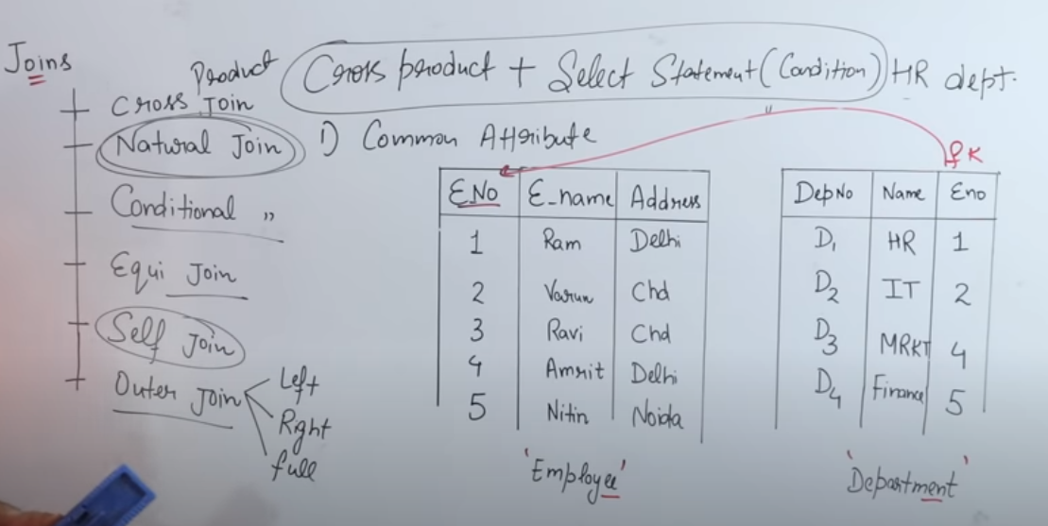

## NATURAL JOIN:

* In this type of join we only consider those values from cross product in which the values of the **common attributes** (FK PK pair) are same.
* Those values are common to both the tables.
* The condition for natural join is:

$$Selectsomethingtable1,table2wheretable1.CommonAttr=table2.CommonAttr$$

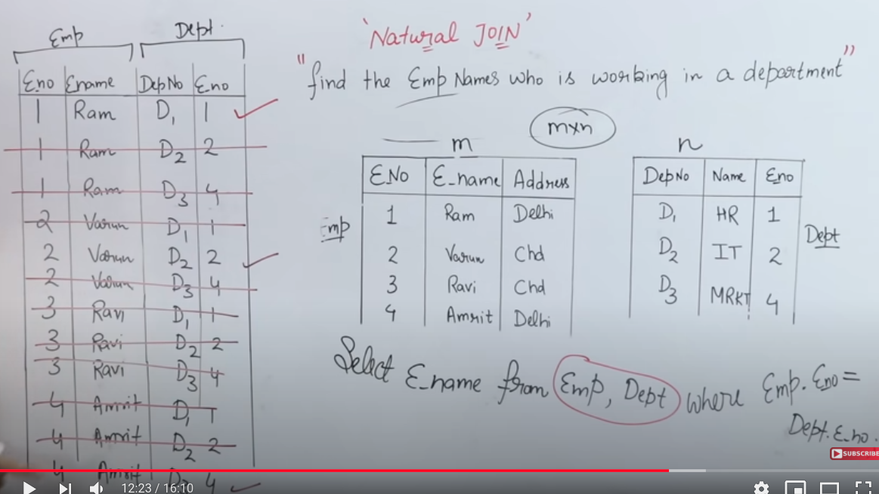

## SELF JOIN:

* Whenever I am joining a table with itself.
* Used to determine conditions within a table.
$$SelectsomethingtableasT1,tableasT2whereT1………….$$

* I am using alias above for table.

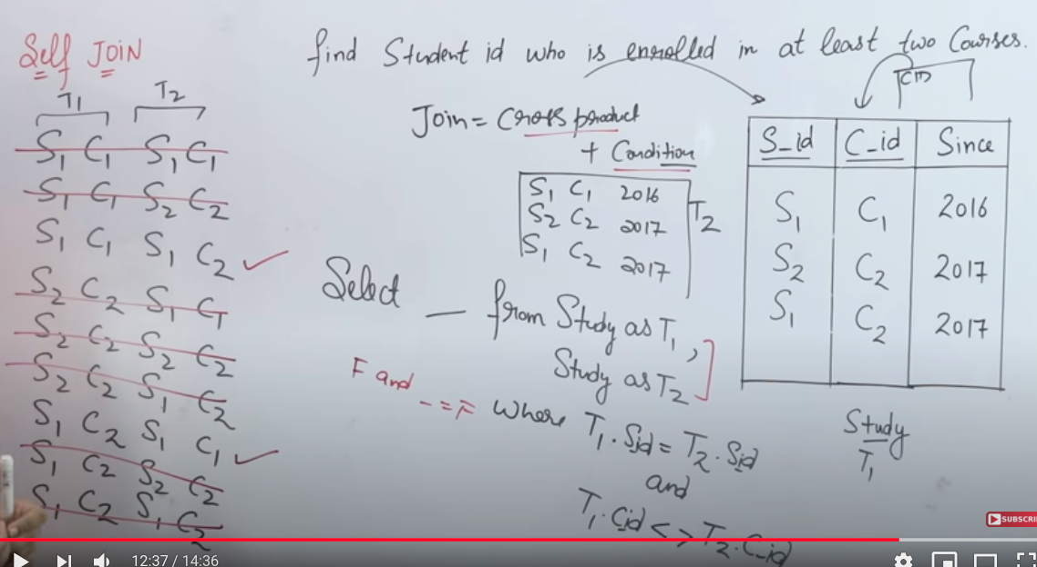

## EQUI JOIN:

* Equi join is a natural join.
* The values of the common attributes are same, but it also considers values of other attributes to be same as well.
* The condition for equi join is:

$$Selectsomethingtable1,table2wheretable1.CommonAttr=table2.CommonAttr∧table1.SomeAttr=table2.SomeAttr$$

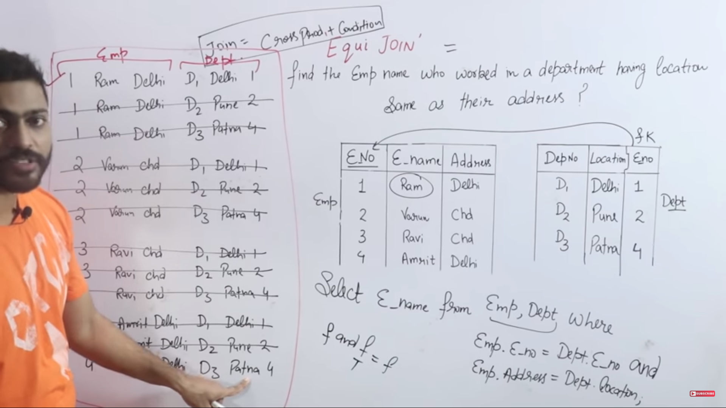

## LEFT OUTER JOIN:

* Type of natural join.
* Displays the rows corresponding to the common attributes (natural join) as well as all the rows of the left table.

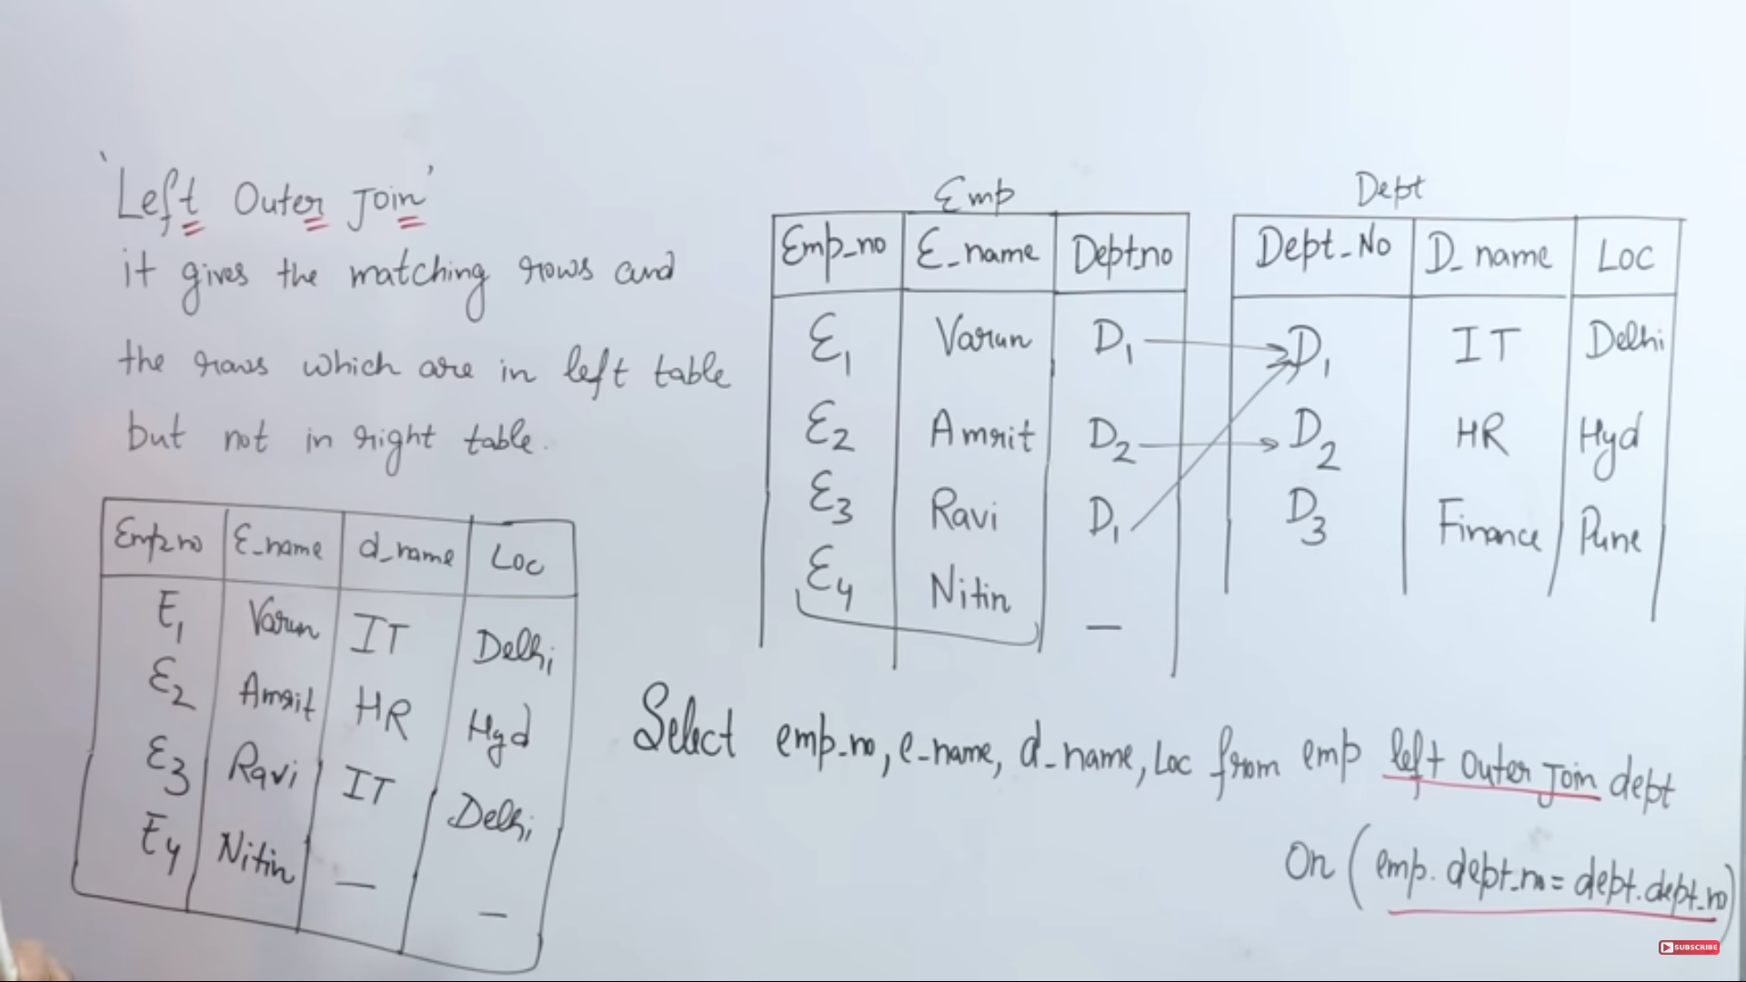

## RIGHT OUTER JOIN:

* Type of natural join.
* Displays the rows corresponding to the common attributes (natural join) as well as all the rows of the right table.

# Why Remove Redundancy?

To remove duplicate data and inconsistency.

To remove data anomalies:

* Insertion anomaly.
* Updation anomaly.
* Deletion anomaly.

# Indexing:

Why use indexing? Sparse indexing, dense indexing.

Types of indexing:

* Primary indexing.
* Clustered indexing.
* Secondary indexing.

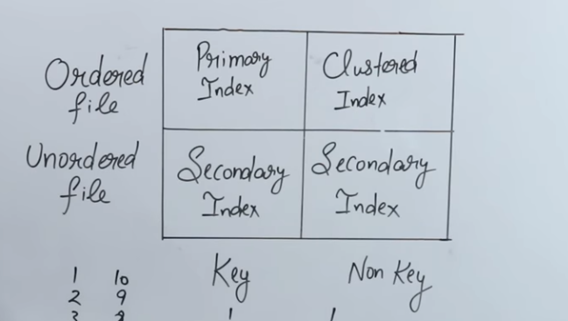

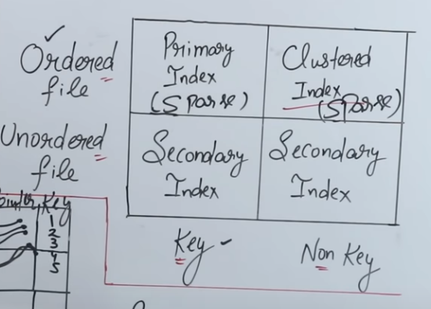

# ACID Properties:

Atomicity

Consistency

Isolation

Durability

# ER Model:

## Types of attributes:

Single VS Multi valued.

Simple VS Composite.

Stored VS Derived.

Key VS Non-key.

Required VS Optional.

Complex Attributes (Composite + Multi valued)

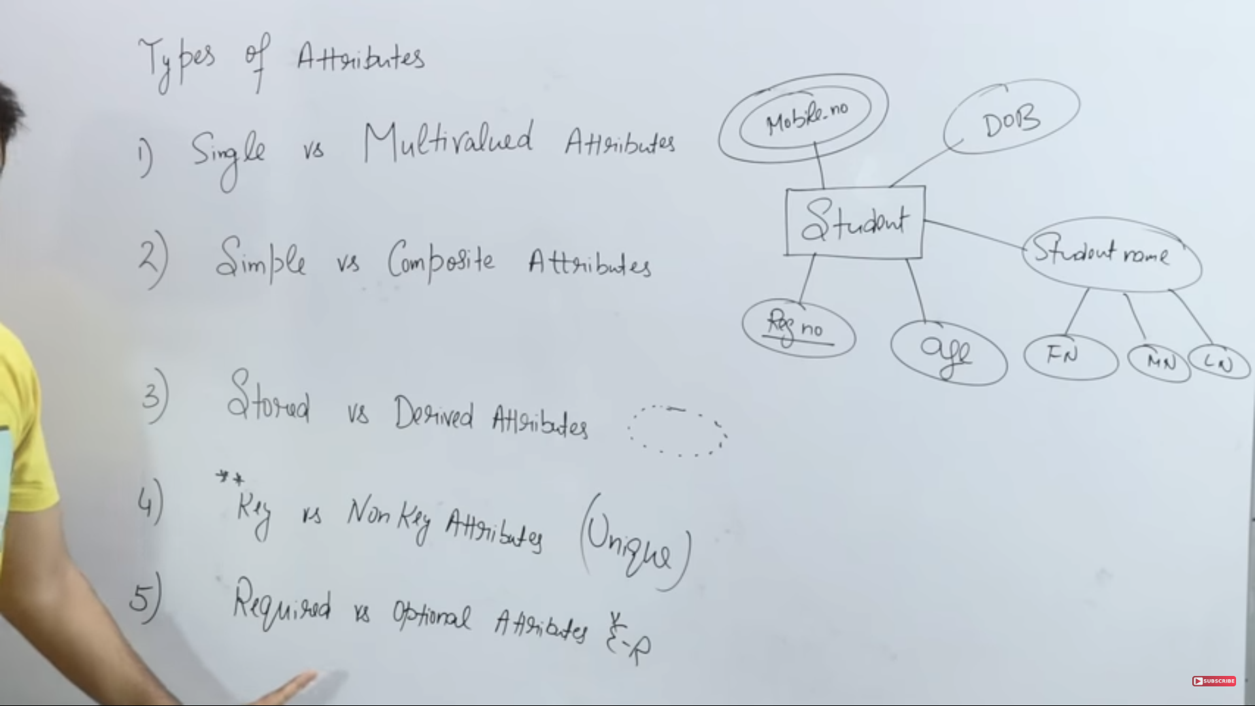

## TYPES OF RELATIONSHIPS (Cardinality):

### One to One:

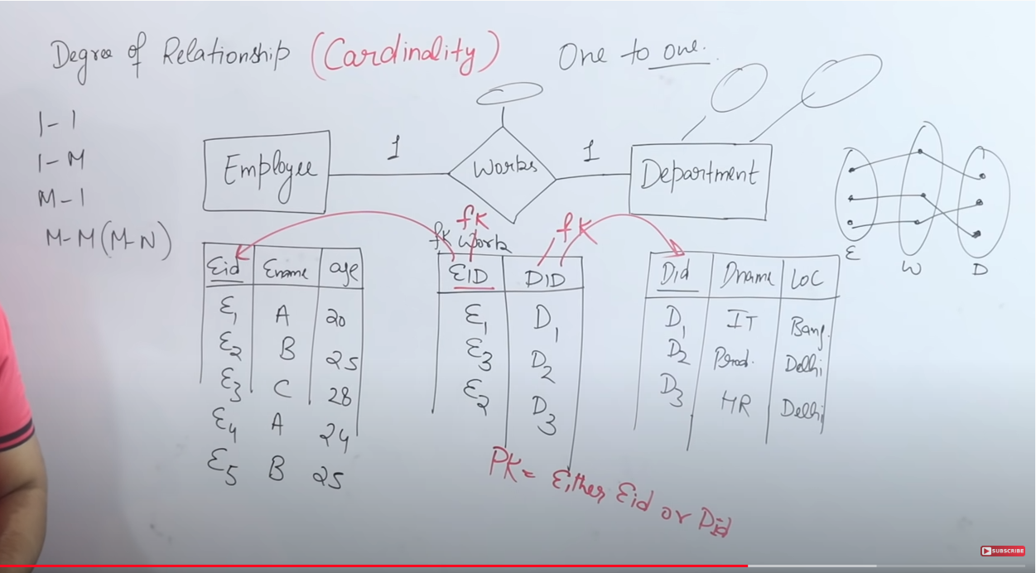

What will be the PK of the relationship table? It can be the PK of either tables. In the above case it can either be EID or DID.

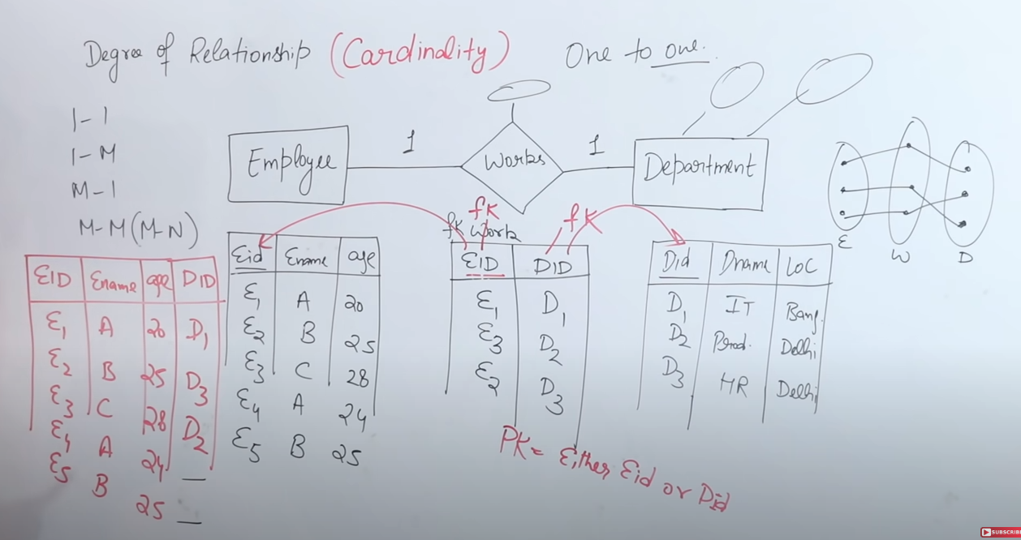

In the above case we have 3 tables. Can we reduce the number of tables? Yes, in the case of One to One relationship, we can merge the two Employee and relationship table as show below in red.

### One to Many:

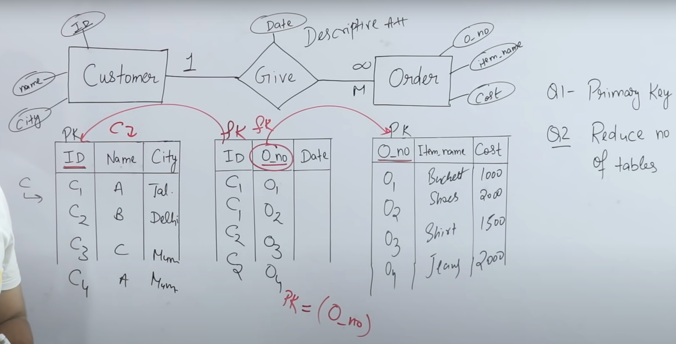

What will be the PK of the relationship table? The PK will be the PK of the MANY entity.

Can we merge the tables to 2? Yes as shown below:

## 

### Many to Many:

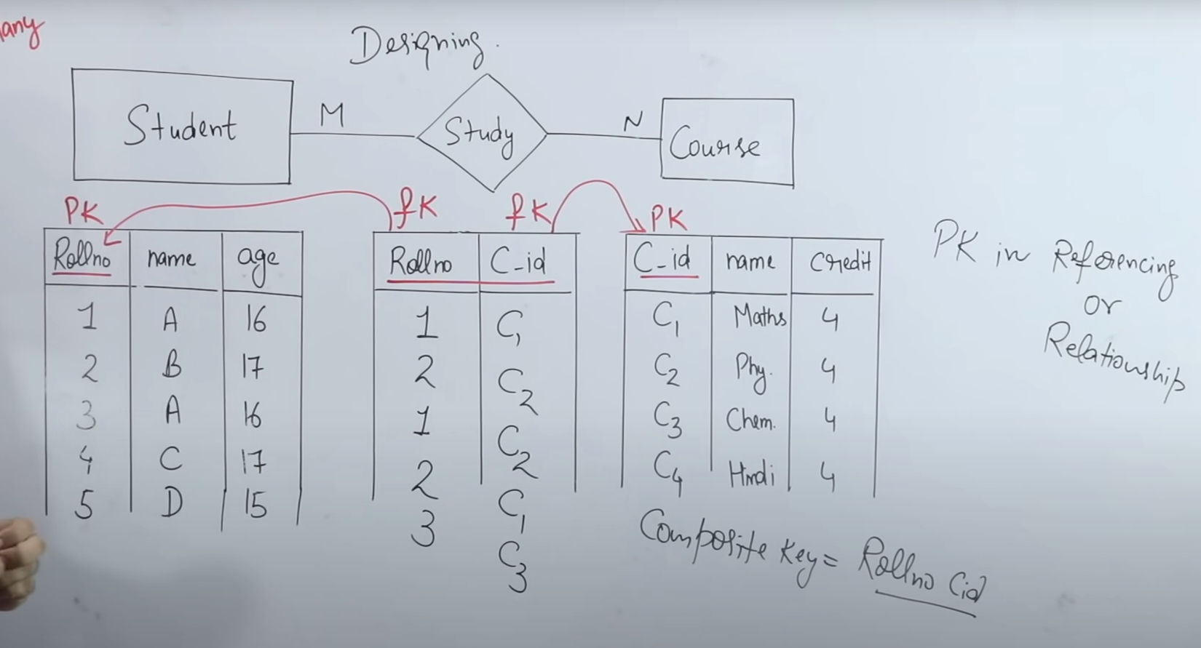

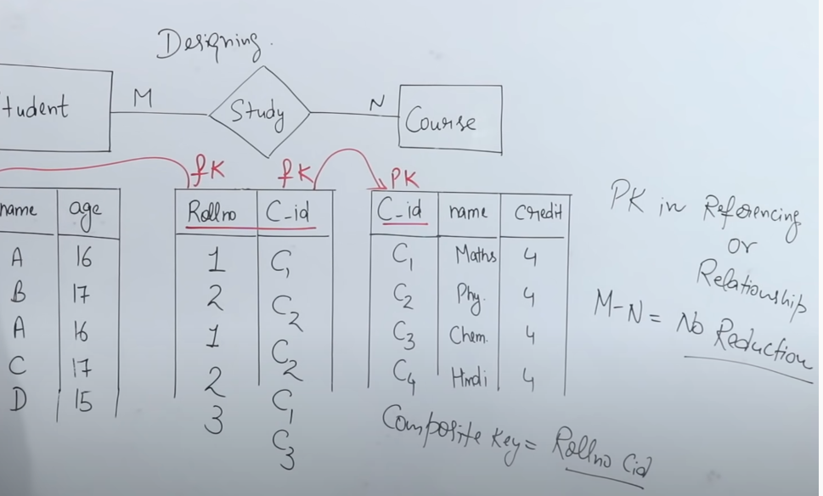

# Views:

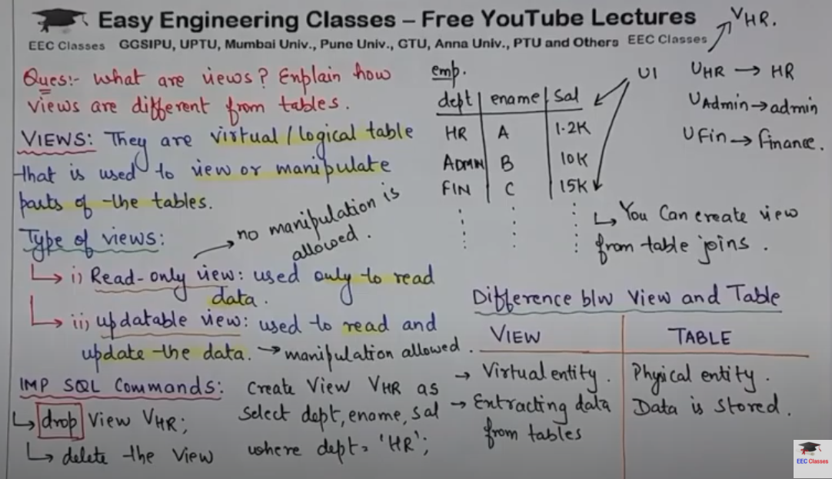

Creating and deleting views (replace is optional for creating views, it’s actually used to update a view):

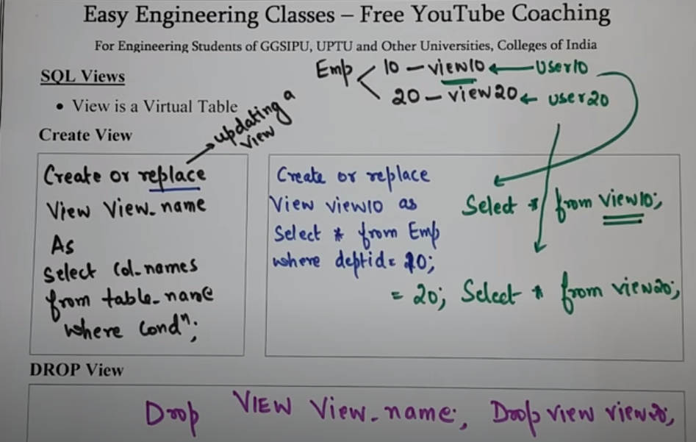

# Delete VS Drop VS Truncate:

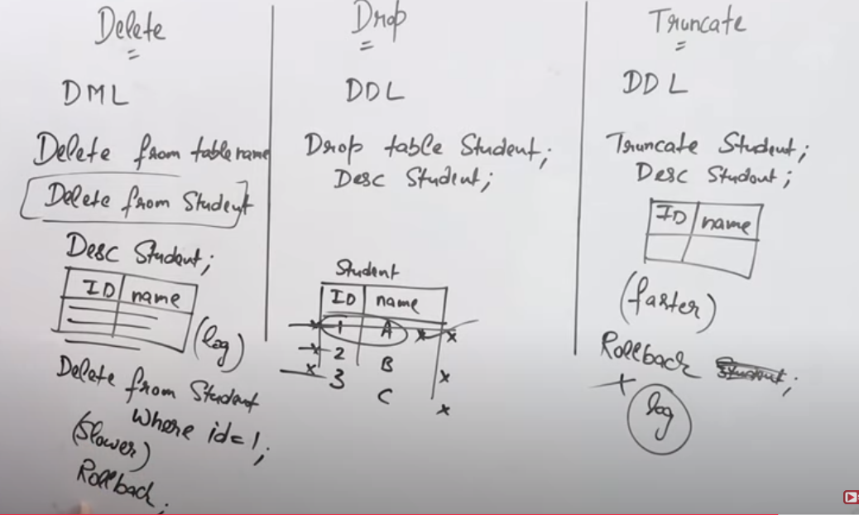

DSA

# AVL Trees:

An AVL tree is a balanced BST:

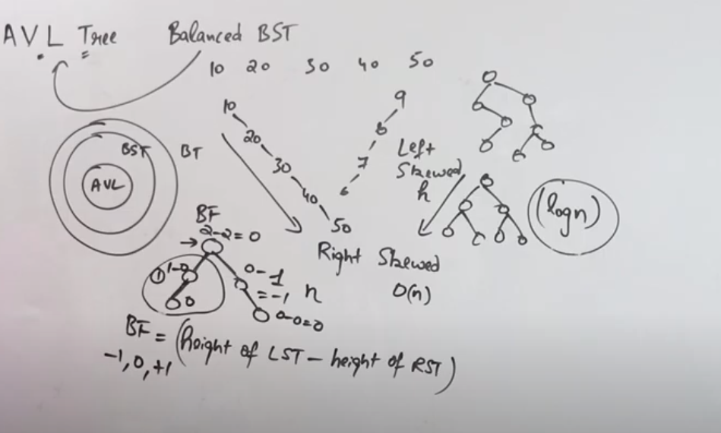

Basic types of AVL trees: LL, RR, LR and RL:

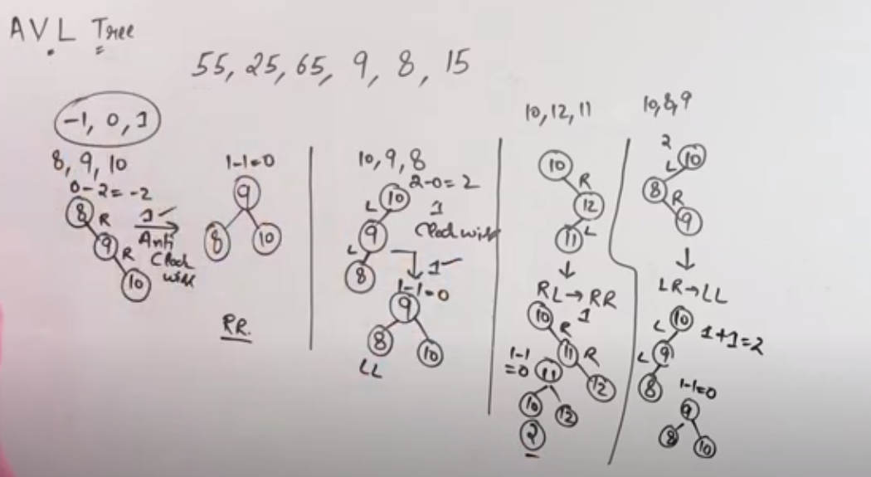

Solving a AVL tree problem:

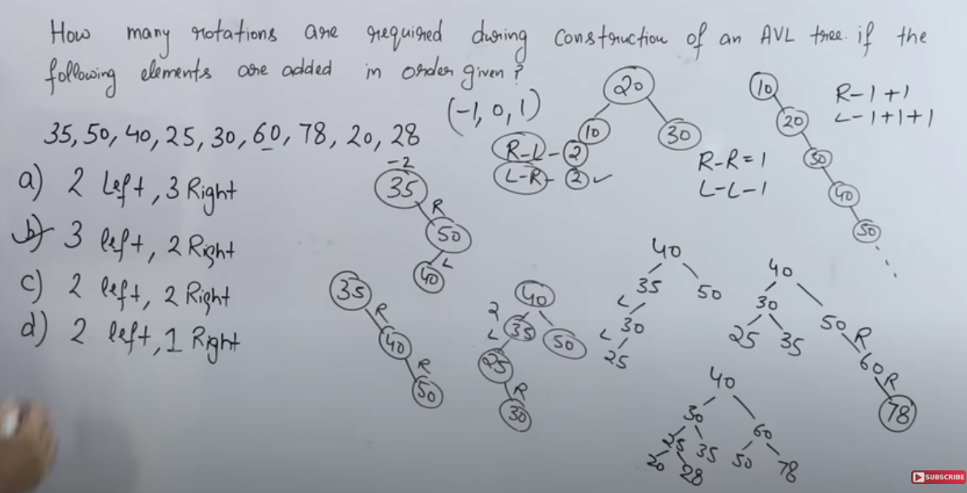

# Quick Sort:

Average Time complexity : **n log(n)**

In the average case the pivot element comes in between the array in the first pass.

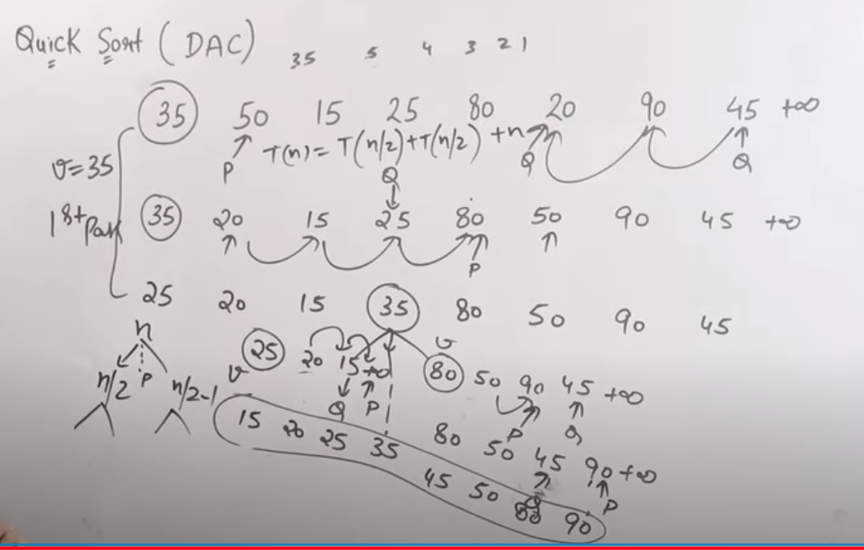

In the worst case, the array is either already in ascending or descending order. In ascending order the pivot element stays in its position while in descending order it goes to the last position on every pass.

The time complexity in the worst case: **log(n2)**

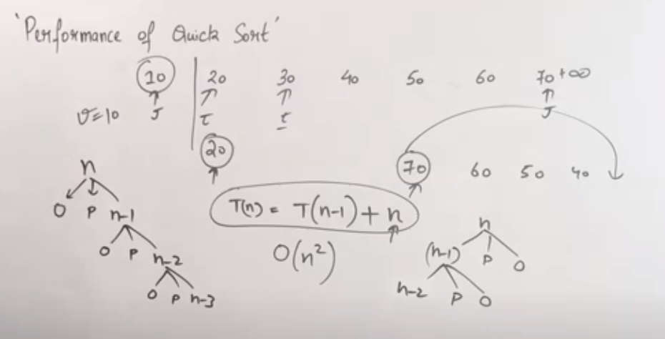

# Bubble Sort:

Time complexity: **O(n2)**

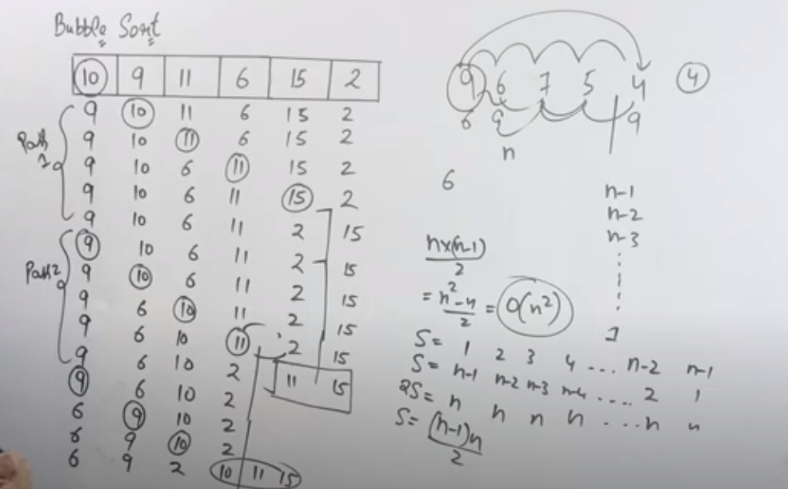

# Insertion Sort:

Best case time complexity (array already in ascending order): **O(log n)**

Worst (array in descending order) and average case: **O(log n2)**

Initial Array in the following diagram is **[7 2 4 1 5 3]**

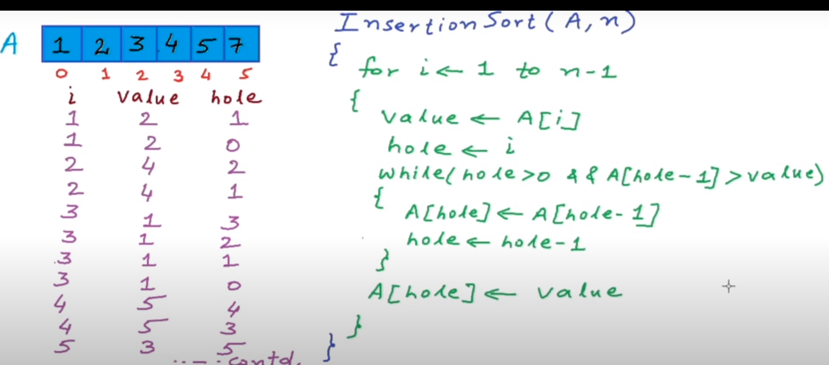

# Merge Sort:

Time complexity for worst case: **O(n log n)**

Space complexity if we do not clear out auxiliary space: **O(n log n)**

Space complexity if we clear out auxiliary space: **O(n)**

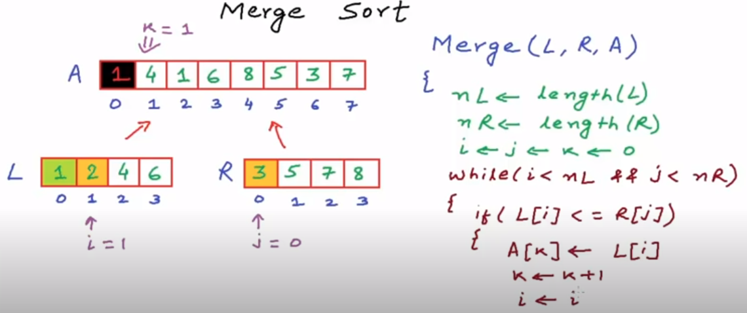

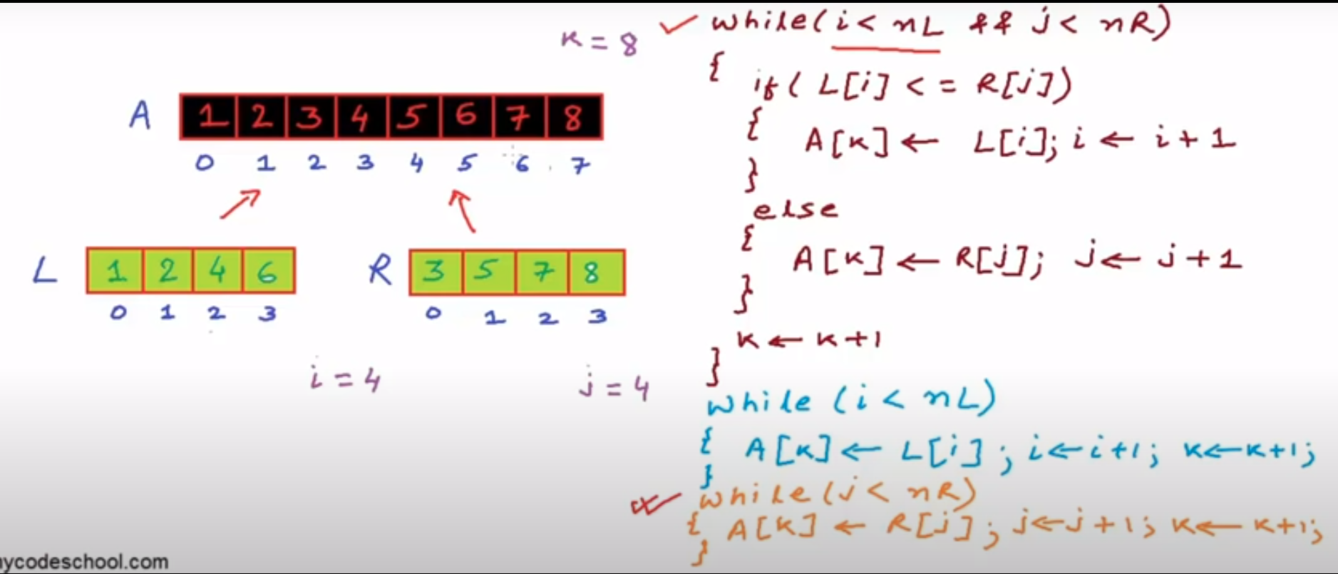

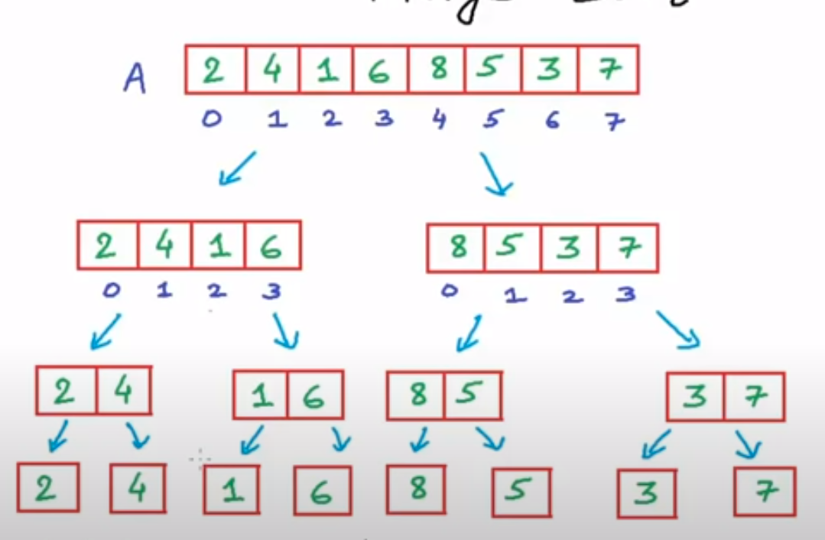 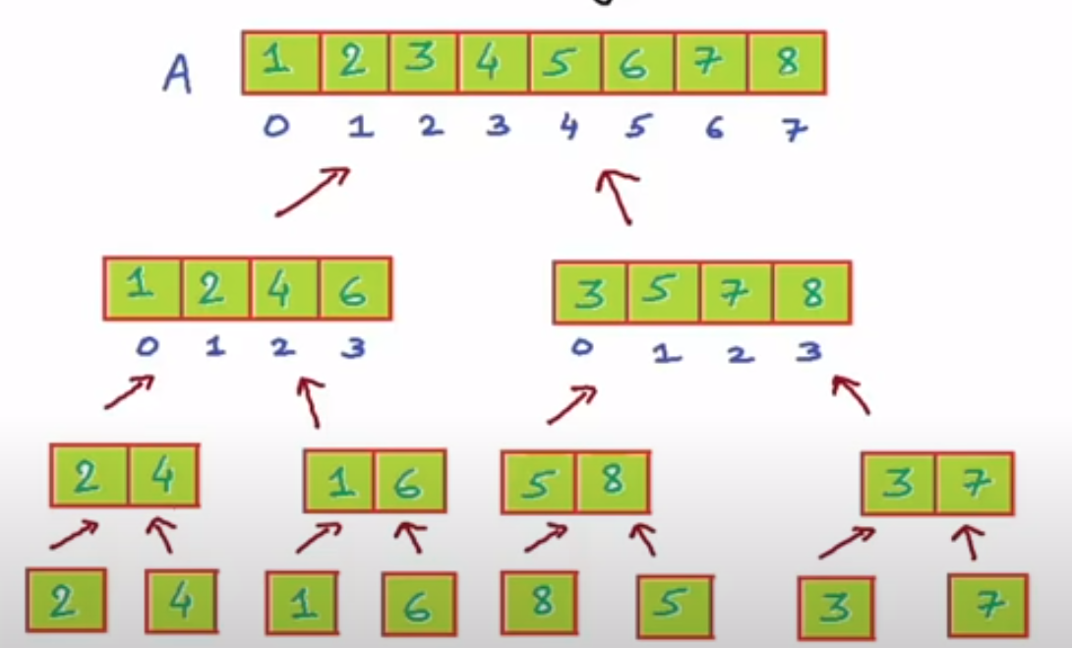

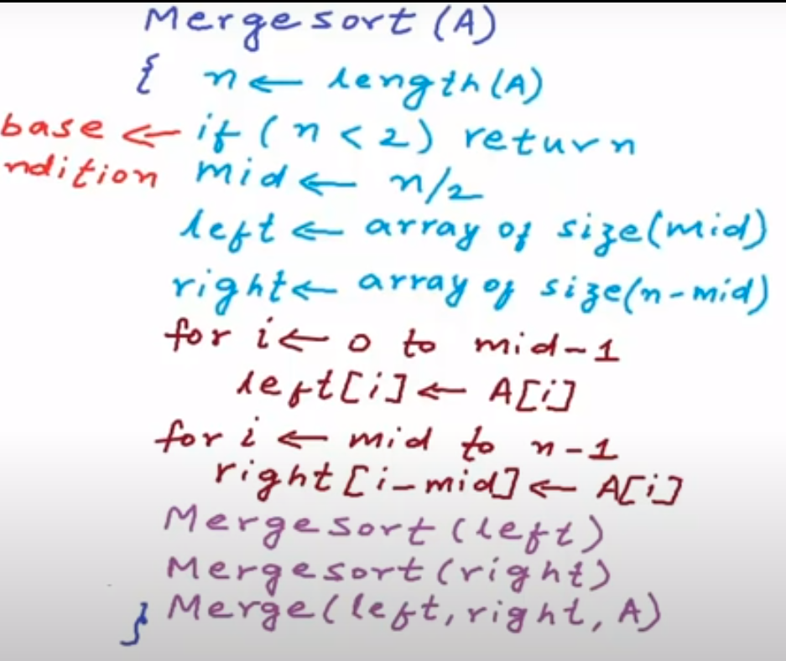

# BFS:

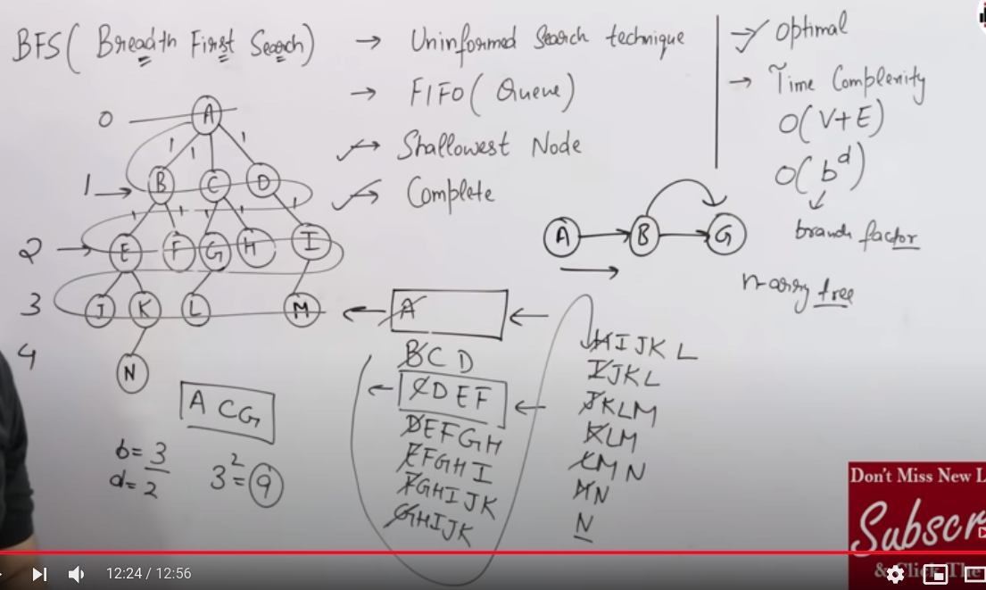

# DFS:



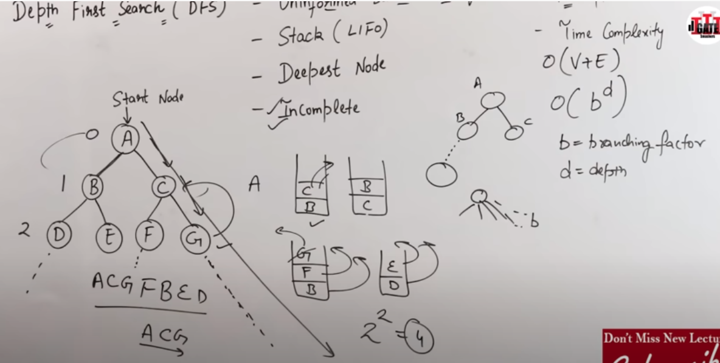

OOP

# FOUR PILLARS:

## Abstraction.

* Access specifiers: Public, private and protected.

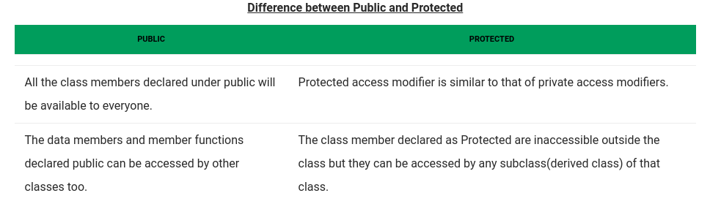

## Inheritance

* Public, protected and private inheritance.

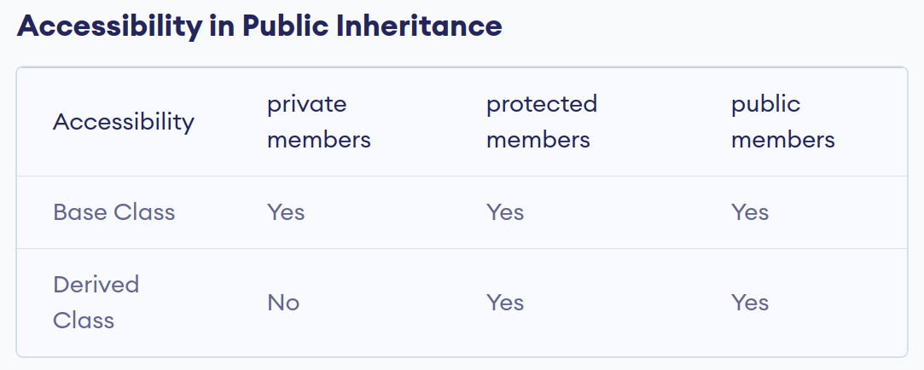

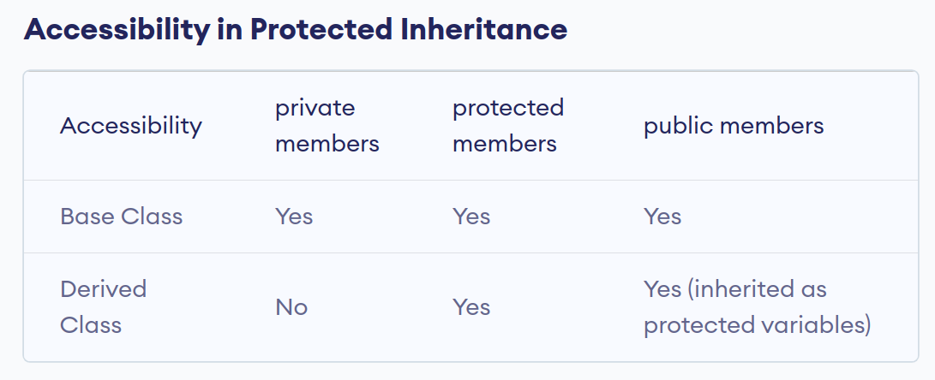

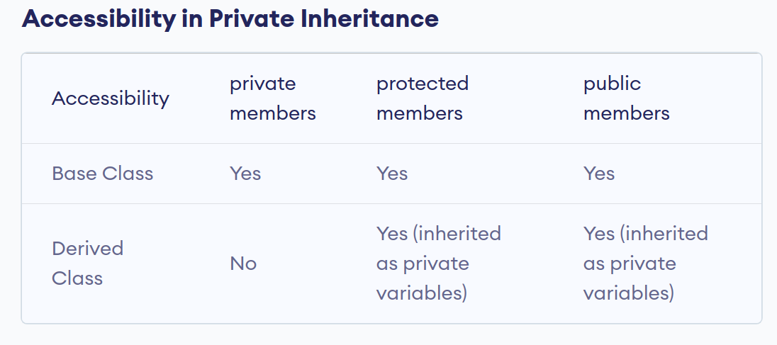

## Polymorphism:

* Static / Compile Time Polymorphism:
  + Function Overloading.
  + Operator Overloading.
* Dynamic / Runtime Polymorphism:
  + Function Overriding
  + Virtual Functions.
* Pure Virtual Function.
* Abstract Class.

# DESIGN PATTERNS:

# Some Topics to Cover:

## DBMS:

1. Truncating /Drop / Delete a table.
2. Views. Why do we need them? Change in views when original tables changes.
3. Join vs Sub-query
4. Foreign keys null
5. Triggers.
6. Normal Forms.
7. Joins.
8. Write a query to get the count of a value that is repeated the maximum times

## OOP:

1. What architecture design is high in cohesion?
2. UML diagram.
3. A universal remote is used to turn devices (AC, TV, etc) on and off. How will you describe this functionality in code? Does a design pattern apply?
4. Friend function.
5. Study Design patterns.
   * Observer pattern.
   * Decorator Pattern.
   * Factory Method.
   * Abstract Factory method.
   * Singleton.

## Programming:

1. Static class, static functions.
2. Ref.
3. Given 2 arrays A and B, give all the pairs in A and B (e.g. A[i], B[j]) that give a sum of k. (Note: there is a solution with O(nlogn) and also with O(n) by using hashing)
4. Given a function that generates a random number between 20-50, write a function that generates a random number between 10-70. (scale approach)
5. Write a program to find the first non-repeating letter in a string. For example, “abbcdaa” then “c” is he first non-repeating letter. Can you go better than O(n2).
6. Find duplicates in an array without using HashMaps in O(N) ?
7. Write recursive code to traverse bst in order.